INVITATION
Dear : Agent & Inventor

Welcome to 2024, The 13th World Invention Creativity Olympic (WICO).

I really want to meet 13th World Invention Creativity Olympic(WICO) 2024 will be held in Seoul Korea from July 24th to 26th.

Participants in the world's first International Invention Olympics, where approximately 2,000 people from 25 countries participate every year to discuss and present their country's science and technology and invention techniques, will receive the best treatment and experience from the Korean government.

As a member of Wiipa, a creative international scientific organization, I am free, safe, and happy.

The WICO event, which provides travel and the opportunity to win Grand Prix gold medals, is a major international event that is designated as a KUIA world scientific organization and is reflected in the admissions policies of American universities.

We cordially invite you to participate in the 2024 international event, WICO.

Yours sincerely,
2024. 04.
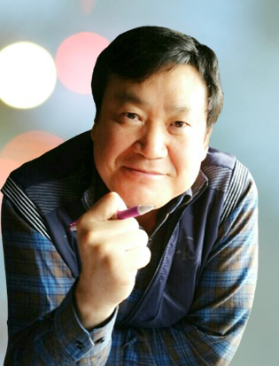 | Ph. D, Economic & Engineering / Lee Ju hyung  ∙ Kongju National University / Professor  ∙ Korea University Invention Association / PresidentRepublic of Korea  ∙ Asia Lohas Industry Certification Association / President

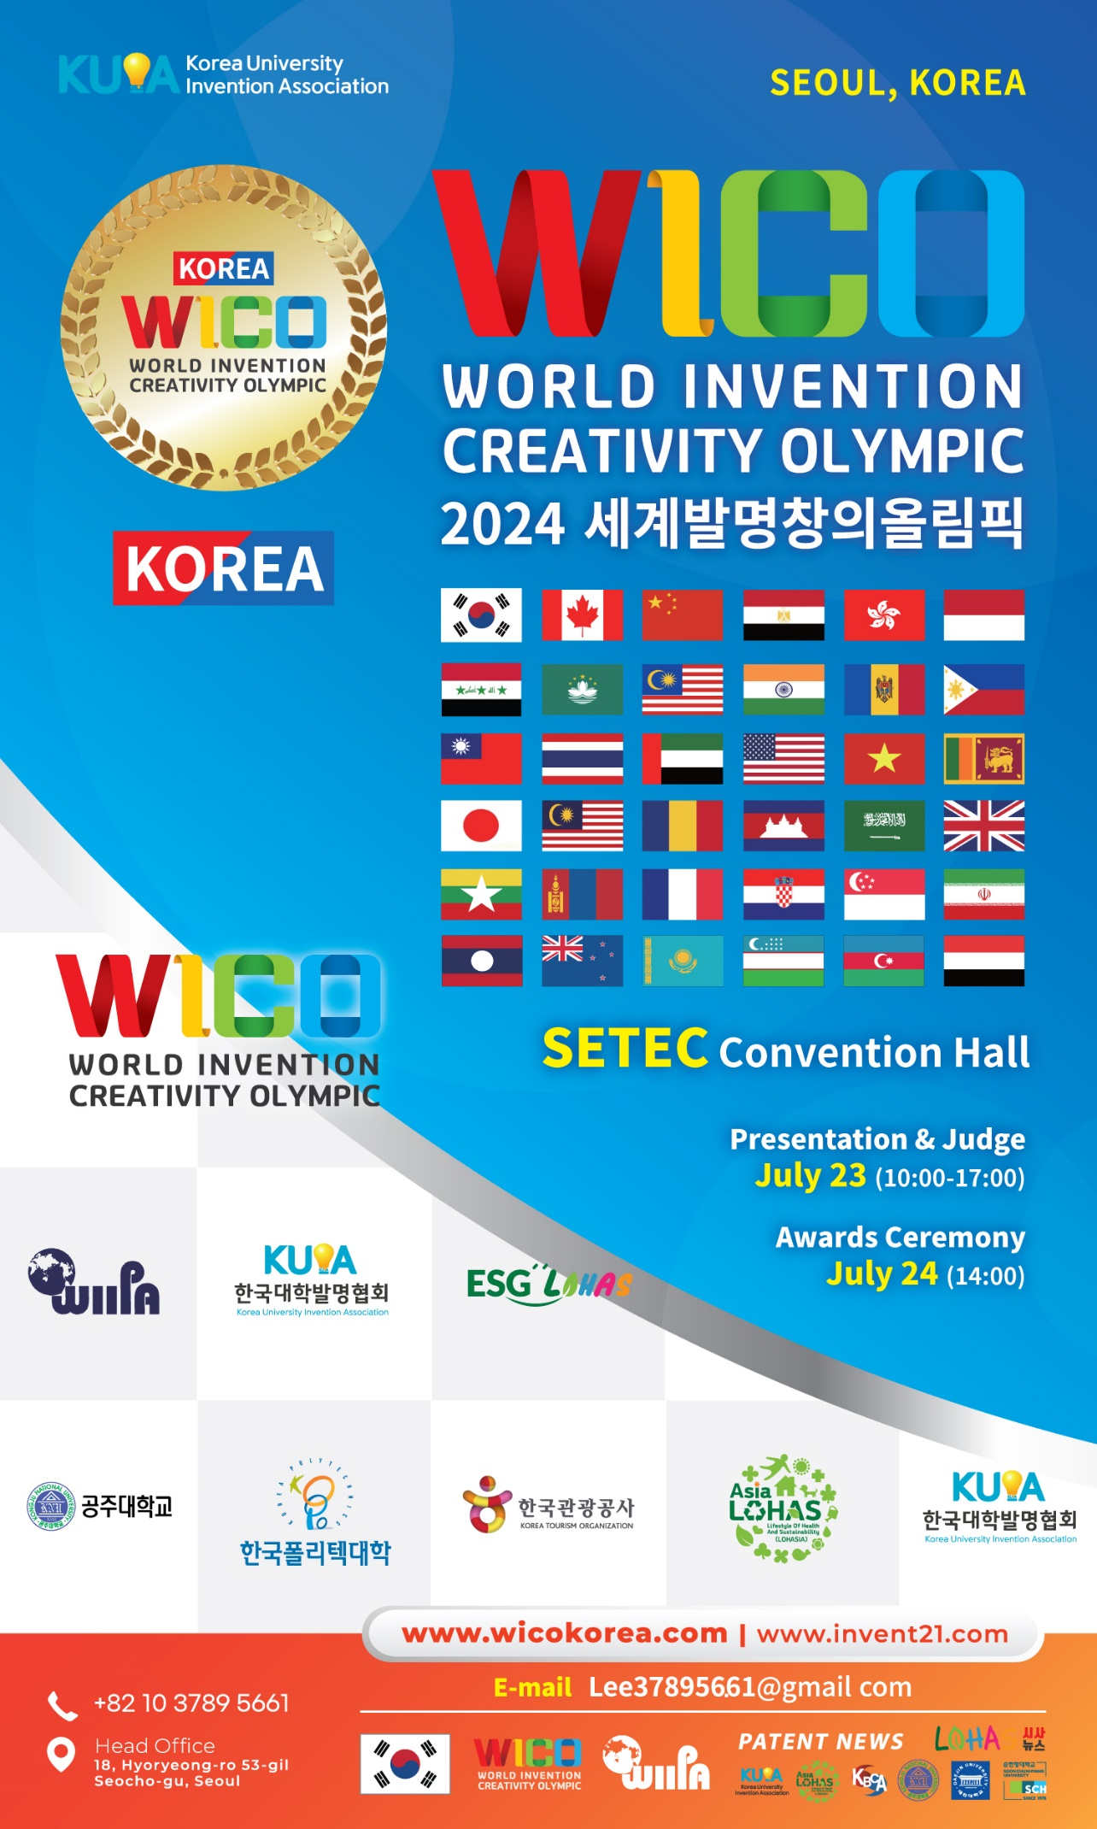
1. Application and Reception
Application period | ~ June 10 2024
Method of reception | - 7935111@ naver.com (KOREN)
 | - Lee37895661@ gmail.com (Foreign)

2. Schedule
Exhibition & Event period | July 23 ~ 24, 2024
Awards Ceremony (Participant) | July 24, 2024

3. Participation Classification
Age Group |  | Award
Student | Elementary, Middle, High, and College Students | Grand Prix Award, Gold, Silver, and Bronze
Individuals / Companies | Corporate Products | Grand Prix Award, Gold, Silver, and Bronze

4. Evaluation Criteria
CRITERIA | DESCRIPTION | Prior Judge | Final Judge
IDEA | Creative and Innovative. | 50 | 30
Technology | Different from existing technology and progressive. | 20 | 20
Practicality | It has high commercial potential | 30 | 0
Presentation | Explaining features clearly and comprehensively, answering questions well. | 0 | 50
Total Score |  | 100 | 100

5. Award Planning
Main Prize | Grand Prix (1%) Gold Award (29%) / Silver Award (40%)  / Bronze Award (30%)
Special Award | K - Edison Award : 1 Item by item  Special Offshore Prize : Special Award of the International Institute of Inventions
* Select one of the best inventions in each field Edison Award

6. Fee
1. Member (Wiipa. IFIA. WIPO. Other WICO authentication) (*Foreigners only)
Entry Fee | Students / ( 1 ) invention) | Corporation
Member & agency | USD ? | USD 900 / each
Not a member | USD

* Additional certificates of award and medals for those who participate in a team can be purchased at $100
* Shipping cost USD 100~200 (consultation by country)

7. Deposit Account
Official Name of Bank | INDUSTRIAL BANK OF KOREA  (BIC, SWIFT CODE : IBKOKRSE
Adress | 18, Hyoryeong-ro 53-gil, Seocho-gu, Seoul, Korea
Beneficiary | 055-059806-56-00011
 | Lee, Ju Hyung

8. Poster and presentation method (A Guide to Participation and Judging)
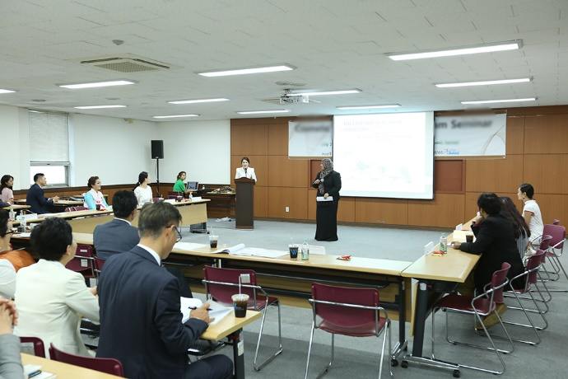
** Depending on the circumstances of the event venue, the presentation method may be a video presentation or a presentation on stage.
* Evaluation method : (1) When submitting an application, submit a 3-5 minute presentation video in advance.
(2) Announce questions from the judges if necessary
Poster Size : 0.9m x 1.5m / Independent booths have separate consultations

9. Exhibition Location

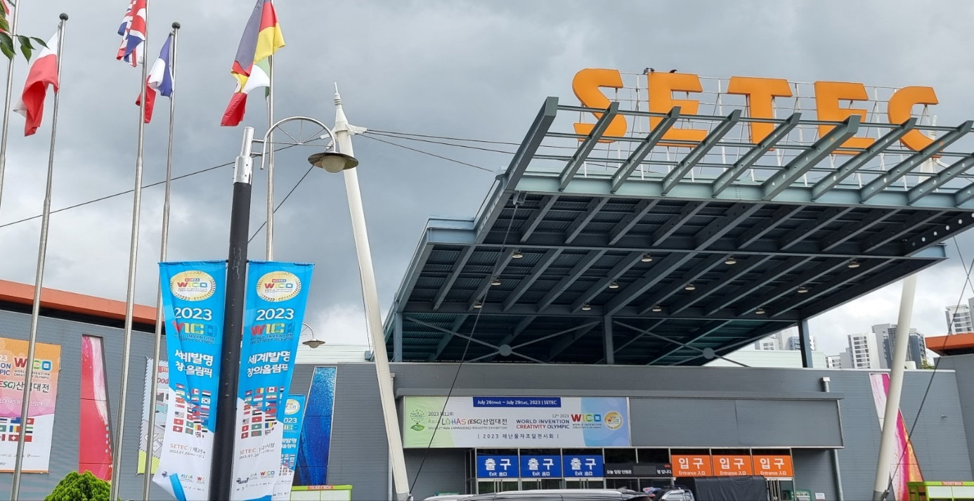
The event location will be announced again once confirmed.

10. Organiser Contact info
Website : www.wicokorea.com / www.invent21.com / www.asialohas.org
E-mail : Lee37895661@gmail.com
Tel : +82 10 3789 5661
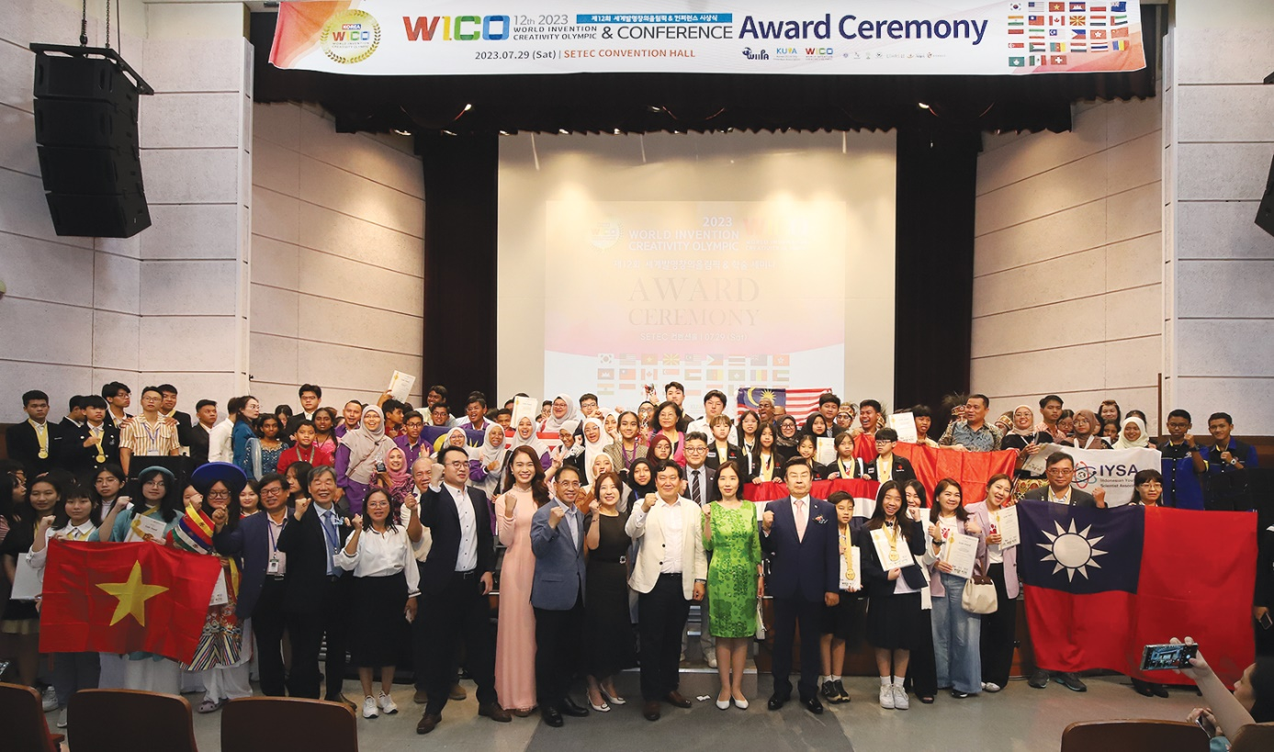
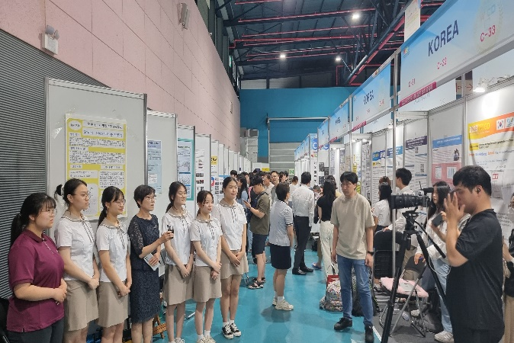 | 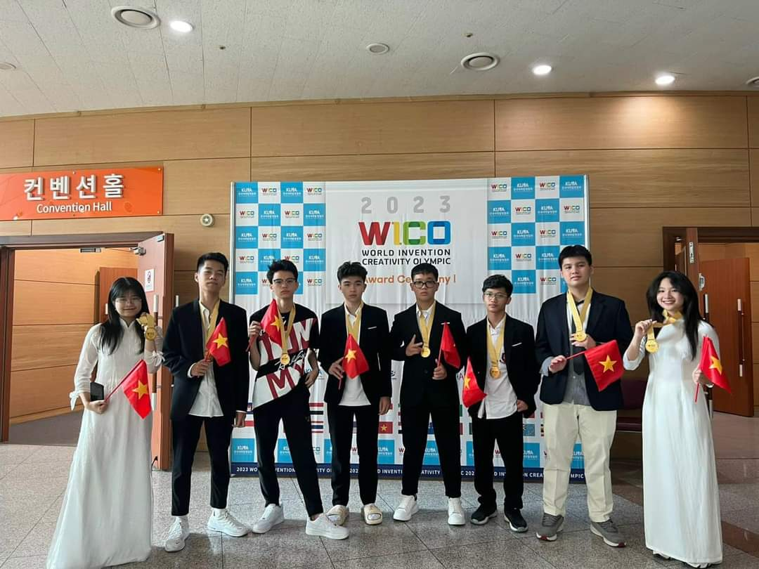
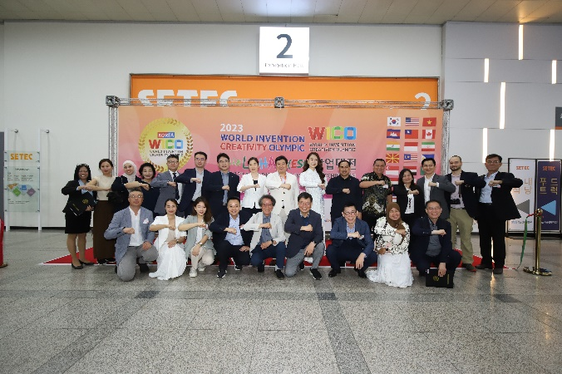
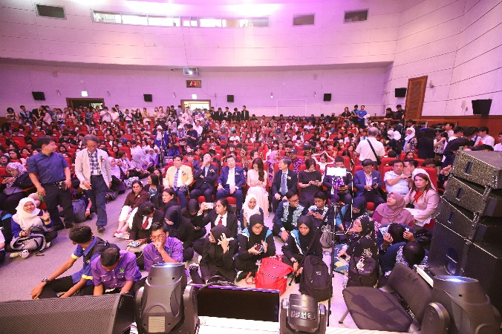 | 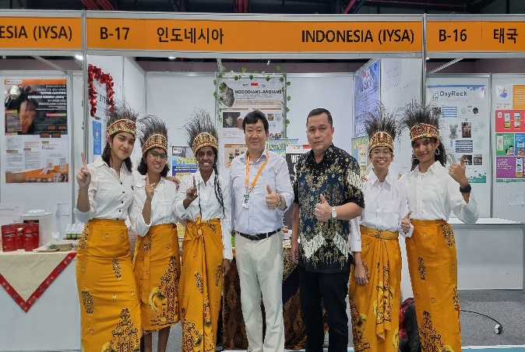
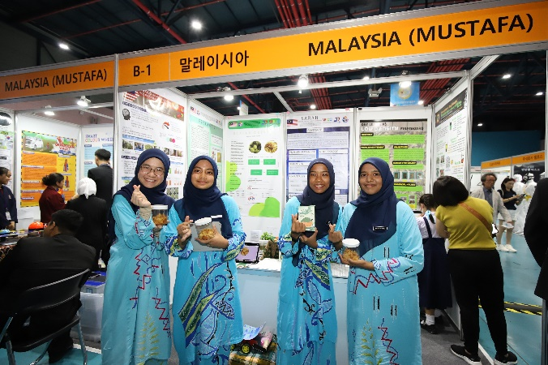 | 